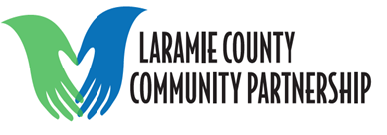
Behavioral Health Action Team Minutes
Date: 6/8/2021
Time: 1:00 pm-2:00 pm
Location: Public Safety Center
Topic: | Information:
LCCP Recruiting Board Members | - Laramie County Community Partnership is recruiting new board members.  - If you are interested contact Amy Spieker (Amy.Spieker@crmcwy.org) or Catherine Villnave (CVillnave@lccc.wy.edu)for more information.
Suicide and Self Harm Dashboard | - Suicide and Self Harm Dashboard  - https://sites.google.com/wyo.gov/wyinjurydata/suicide-and-self-harm
Narcan | - CRMC has been working on an option to provide Narcan to those that come into the ED who are needing it.  - The individual would still be required to have prescription.  - Training would be provided to the individual when picking up Narcan.  - If you are or know anyone interested in Narcan training let Brittany or Angela know.  - If you know an organization that would like to have Narcan on hand let Brittany or Angela know.
Updates | - NO MEETING IN JULY  - Next Meeting: August 10, 2021  - The meeting will be in person at the Public Safety Center in Cheyenne, Wyoming.

